System drought indicator for the Southern California hydrologic region

# Water portfolio of the Southern California hydrologic region

Water Data Portfolios is used to obtain the supply portfolio for the 2002-19 period.

The main sources which compromise around 83% of the supply in southern California are:

* State Water Project (SWP) - 24% of the supply
* Colorado - 22% of the supply
* Groundwater - 33% of the supply
* Los Angeles Aqueduct (Imports)- 4% of the supply

# Estimating supplies using drought indicators

## State Water Project

Given SWP supply comes from Northern California, we try correlating swp supply with delta surface water drought indicator (SWDI).

Different datasets are used to better understand the relationship between indicators and state water project.

### DWR (Water Data Portfolio)

We correlate SWP data with water year SWDI delta indicator. Some correlation is observed (r2=0.435) as seen in figure 1. Generally during dry years when SWDI delta is low, less water is delivered. However, in normal years (SWDI between 0.4 and 0.6), deliveries can vary by as much as 1,000 MAF. This variability may be due to water being stored outside of SoCal to ensure adequate supply during future drought years.

Figure Monthly average SWDI over the water year vs SWP deliveries over the water year.

2006 regulation changes (2006 Bay-Delta Plan) negatively impacted deliveries to SoCal from 2008 and on. By dividing the SWP deliveries to pre 2008 and post 2008 deliveries, a noticeable decrease in SWP deliveries is observed. Pre-2008 deliveries always exceeded 1400maf, whereas post-2008 deliveries have not exceeded 1300maf. Furthermore, no improvement in correlation is observed (Figure 2).

Figure Monthly average SWDI over the water year vs SWP deliveries over the water year.

Moreover, correlating DWR with SWDI SC yields similar results (r2=0.3843). As shown in figure below

By dividing into pre and post 2007, noticeable improvement in r2 is observed (pre2007: r2=0.696 and post2007: r2=0.553)

### SWP Allocations

Write more about SWP allocations. About how it was divided into ag and ub before.

DWR publishes a percent allocation for SWP contractors at the beginning of each water year based on availability of supply in the delta. Initial allocations are conservative and generally allocations increase throughout the year.

The figure below shows the allocation percentages by the final of each water year. 1995-2000 was a very wet period as the allocations were around 100%.

SWDI delta is used to determine SWP allocations. The correlation between the average calendar year SWDI and the annual allocation (final allocation at the end of each year) is r2=0.7594. This score is higher than the average water year SWDI (r2=0.6939) and the correlation with the SWDI at the time the allocation is published (r2=0.7025) as shown in figure below.

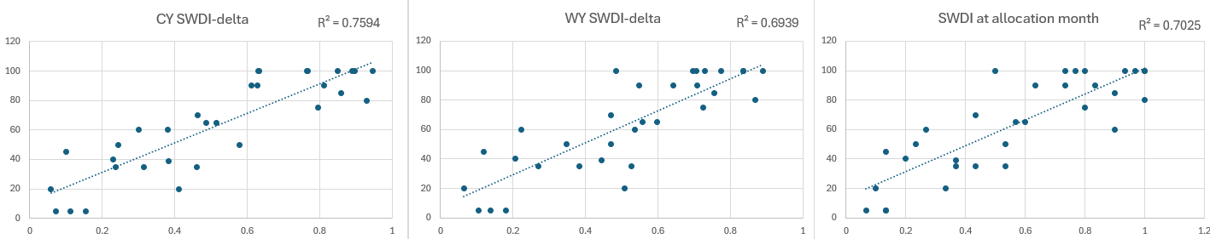

### B132-19 report

(just recently b132-20 was released)

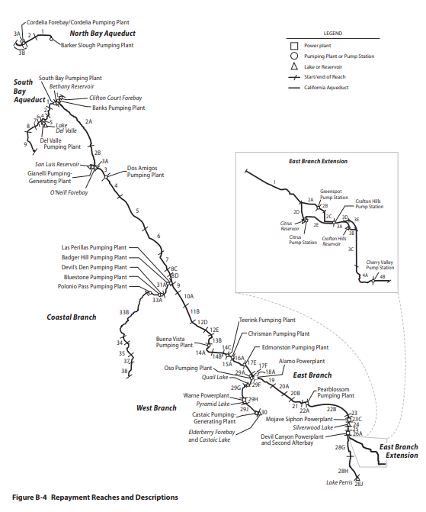

This report provides a detailed explanation of California State Water Project Management for each calendar year. Full reports of the State Water Project for each calendar year are released after a few years. For example, the full report for:

* B132-2019 was released in 2022
* B132-2018 was released in 2021
* B132-2017 was released in 2019
* B132- 2016 was released in 2017

Up until the release of the full report, appendices are provided annually.

Our focus is on the deliveries. Relevant tables related to our project include:

* Table B-4: Maximum Contractual Table A Amounts
* Table B-5A: Annual Water Quantities Delivered from Each Aqueduct Reach to Each Contractor

This shows amounts of actual allocated water quantities delivered from each aqueduct reach to each SWP contractor

It also includes non-project water delivered to SWP water contractors, surplus water deliveries prior to May 1, 1973, and actual Article 21 water deliveries in 1994 and thereafter.

* Table B-5B: Annual Water Quantities Delivered to Each Contractor

This presents a summary of actual and projected annual allocated water quantities for each SWP water contractor. The quantities also include amounts of non-project water and surplus water delivered prior to May 1, 1973, and actual deliveries of Article 21 water in 1994 and thereafter.

* Table B-6: Annual Water Quantities Conveyed through Each Pumping and Power Recovery Plant of Project Transportation Facilities.

This summarizes the annual allocated water quantities conveyed or to be conveyed through each aqueduct pumping plant or power plant.

The following is for 2018 only:

* Table 8-1: Storage of Water Outside SWP Contractor Service Areas in 2018
* Table 8-5 2018 Allocated Table A Amounts
* Table 8-6 Water Delivered to SWP Contractors in 2018, by Service Area
* Table 8-7 Total Amounts of Water Delivered in 2018, by Month

Extra:

* Table 8-8 Total Amounts of Annual Table A Water and Water Conveyed, by Type, 1962–2018
* Table 8-9 SWP Water Delivered by Category, 1962–2018

This is for each category in table A delivered (Municipal, Ag), Article 21 and other SWP water deliveries (feather river diversions, fish wildlife and other)

* Table B-5A-Adj:

This presents a summary of accounting adjustments that result from water deliveries not originating from the Sacramento-San Joaquin Delta (Delta).

The methodologies used to calculate various components are based on cumulative charges from the Delta through facilities conveying water to a specific repayment reach. When water is introduced to the SWP downstream of the Delta, SWP water

**SWP Water.** as defined in the SWP Water Supply Contracts, includes Article 21 water, carryover Table A water, current year Table A amounts, transfer and exchange of Table A water, and Turn Back Pools A and B. Detailed information concerning those conveyances for 2018 is found under the “Miscellaneous Agreements with SWP Contractors” section in this chapter’s preceding pages or is listed below.

**Non-SWP Water.** In 2018, DWR used SWP facilities to convey non-SWP water to various non‑SWP agencies according to the terms of water rights and water transfer and exchange agreements. Detailed information concerning those deliveries is in this chapter.

We know total deliveries to all SWP contractors from 1990s to 2022.

Correlating SWDI delta with total deliveries from 2000 to 2022, a relatively high r2 of 0.801 is obtained, similarly with South Coast a r2 of 0.701 is obtained (South coast deliveries are calculated by summing up all the deliveries to contractors located in south coast region). The correlation is slightly higher when looking at the 2008-2022 period with r2 of 0.75 and 0.83 for total deliveries and South Coast deliveries respectively. Lower correlations are observed for the 2000-2008 period with 0.76 and 0.38 for total deliveries and South Coast deliveries respectively.

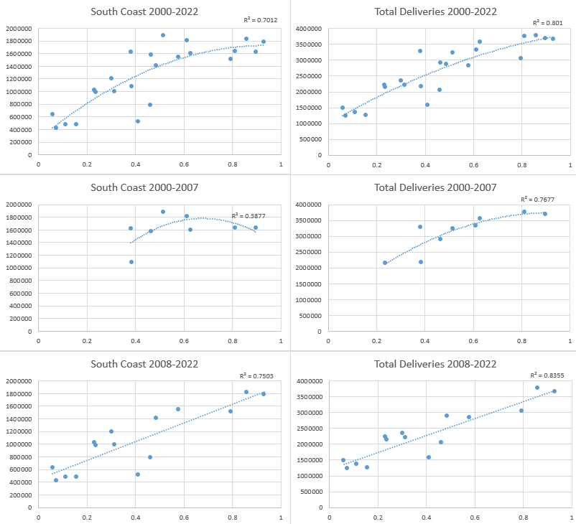

High correlation exists between SWDI delta and total deliveries as evident in the figure above (right), with r2=0.8 for the period 2000-2022. A similar satisfactory correlation is observed with South Coast deliveries, with r2=0.7 for the period 2000-2022. The correlation is lower for both deliveries for the period 2000-2007 (especially the South Coast where r2=0.39).

### State Water Project Final Delivery Capability Report

This report provides historic (past 10 year) SWP deliveries (Table A, Article 21, Carryover and Turnback) to each contractor (2021 report provides historic deliveries till 2011). Below is a snippet of the 2018 deliveries.

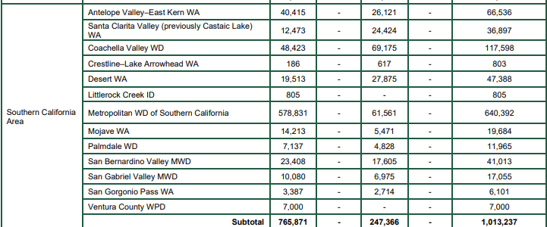

B132 Table 8-7 provides monthly water deliveries to each contractor with categories. B132 and the former have the same values (I compared them manually), however, b132 is more comprehensive because it includes transfers (table A transfers to others or Non-SWP water transfers to others) and water bank recoveries.

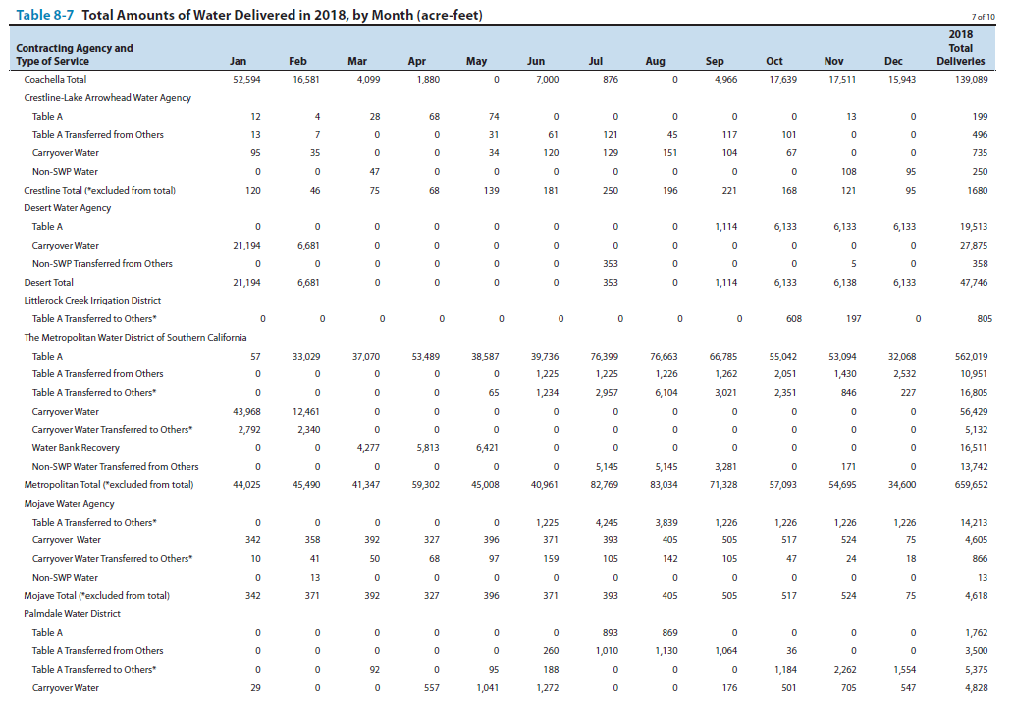

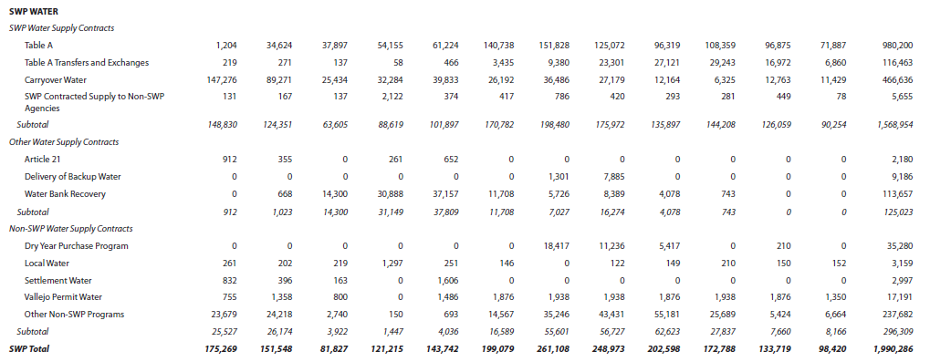

Minor difference exists between table 8-7 total deliveries to contractors (1,990,286 af) and table b-5b (Annual Water Quantities Delivered to Each Contractor) total deliveries to contractors (2,048,447af).

### MWD

Unlike B132-19 report South Coast deliveries, where correlation was lowest for the period 2000-2007, MWD dataset shows highest correlation for that period and much lower correlation for the other period.

### Validating Datasets

High correlation of 0.921 is observed between B135 MWD deliveries and MWD provided dataset. A reason for a difference in the of values could be B135 includes total swp and non swp water deliveries. However, it needs to be investigated, as after 2000 B135 deliveries have been generally higher (most significant years: 2010 and 2011)

A low correlation of 0.49 is observed between DWR portfolio dataset and B135 south coast deliveries. This is expected since DWR dataset is water year whereas the latter is calendar year.

By converting B135 SC deliveries to water year (taking the 3-month average of previous year and 9-month average of the current year, we can approximate the water year deliveries), r2 increases to around 0.6. This value is expected to increase by knowing the exact monthly deliveries. By removing 2010 and 2011 values (bottom left points), the r2 increases to 0.85 indicating monthly deliveries we’re not equal at that period.

More information of validation of DWR dataset with MWD dataset and B135 is available in appendix.

## Groundwater

Groundwater delivery data is only available through water data portfolios. We’ve tried to identify a relationship between the groundwater indicators and the deliveries.

Moderate correlation is observed between the pumping intensity indicator (annual changes in groundwater elevations) and groundwater deliveries (r2=0.5765). No correlation exists between surface deliveries (SWP+Colorado+imports) and groundwater deliveries (r2=0.0024). Figures for both are below.

## Los Angeles Aqueduct

Los Angeles Aqueduct comes from Mono Lake in the Owens valley, located in the Sierra Nevada mountains. Environmental regulations implemented in the 1980s for Mono Lake have led to significant reductions in water diversions which has decreased the supply of the LA Aqueduct.

We will be utilizing SWDI South Lahontan indicator to predict the LA aqueduct supply because it’s located in the South Lahontan hydrologic region.

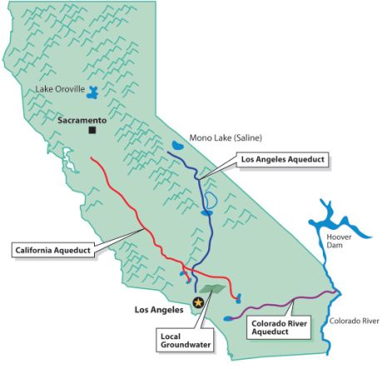

### DWR (Water Data Portfolio)

DWR’s import data is in water year and shows high correlation with SWDI SL WY (r2=0.8624) as shown in figure below. A similar high correlation is observed with SWDI delta (r2=0.8621); This could be because both the Los Angeles Aqueduct and the State Water Project rely on hydrological conditions in the Sierra Nevada mountains for their water supply. Whereas, SWDI SC has lower correlation (r2=0.5976), which makes sense as the water surface condition in SoCal is not reflective of LA aqueduct supply.

### MWD

MWD historic supply dataset spans from 1976 to 2015 as shown in the figure below.

MWD’s Aqueduct with DWR’s Imports data reveals a remarkably high correlation of r2=0.9316. This strong correlation reassures us that the datasets are similar.

SWDI SL indicator (both for water year and calendar year) shows high correlation with MWD Aqueduct (respectively, r2=0.7979 and r2=0.7973)

## Colorado River

### History

Colorado river is governed by two treaties: 1922 Colorado River Compact (Law of the river) and the 1944 Treaty between the United States and Mexico. The compact divided the Colorado River into two sections: the Lower Basin, which includes Arizona, Nevada, and California, and the Upper Basin, which includes Colorado, New Mexico, Utah, Wyoming, and Arizona. Each basin gets 7.5 maf/yr of consumptive use. Mexico gets 1.5 maf/yr plus an additional 200,000 af when a surplus is declared. Thus, annual total consumptive use of 16.5 maf/yr is allocated. The Compact also required the Upper Basin not to deplete the river’s flow to less than 75 MAF during any 10 consecutive years.

The 2 largest reservoirs are:

* Lake Powell: For Upper Basin users (to avoid violation of the non-depletion obligation)
* Lake Mead/Hoover Dam: For Lower Basin users

Lower Basin users and Mexico use all their 9 maf/yr apportionment of the Colorado river whereas Upper Basin consumptive uses averaged 3.7 MAF/year.

In the Lower Basin, Hoover Dam, completed in 1936, provides the majority of the Lower Basin’s storage and generates about 4.2 billion KWh of electricity per year for customers in California, Arizona, and Nevada.34 Also important for Lower Basin Operations are:

* Davis Dam/Lake Mohave, which regulates flows to Mexico under the 1944 Treaty,
* Parker Dam/Lake Havasu, which impounds water for diversion into the Colorado River Aqueduct (thereby allowing for deliveries to urban areas in southern California) and CAP (allowing for diversion to users in Arizona).
* Imperial Dam (a diversion dam), Further downstream on the Arizona/California border, diverts Colorado River water to the All American Canal for use in California’s Imperial and Coachella Valleys (Stern et al., n.d.).

In the table below, Annual Apportionments for each state in the upper and lower basin are found.

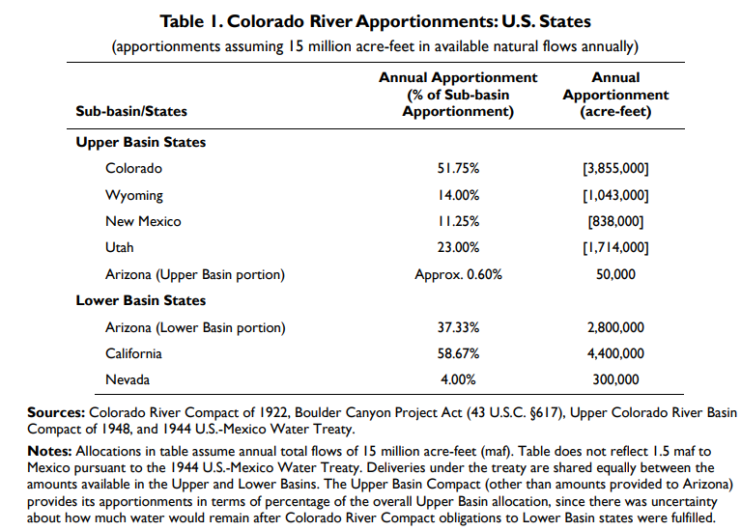

[BOULDER CANYON PROJECT Agreement](https://www.usbr.gov/lc/region/pao/pdfiles/ca7pty.pdf)

* Priority 1: Palo Verde Irrigation District 104,500 acres
* Priority 2:Yuma Project 25,000 acres
* Priority 3: 3,850,000 acre feet equal rights (1,2,3a and 3b should not exceed 3,850,000)
  + 3(a) Imperial Irrigation District and other lands under or that will be served from the All American Canal in Imperial and Coachella Valleys
  + 3(b) to Palo Verde Irrigation District for use exclusively on 16,000 acres in that area known as the “Lower Palo Verde Mesa”
* Priority 4: MWDand/or the City of Los Angeles 550,000 acre feet
* Priority 5:
  + (a) MWD and/or the City of Los Angeles, with an additional entitlement of 550,000 acre-feet
  + (b) The City of San Diego and/or County of San Diego, with an entitlement of 112,000 acre-feet annually. These two rights are equal in priority.
* Priority 6: 300,000 acre-feet
* (a) IID and other lands served by the All American Canal in Imperial and Coachella Valleys
* (b) Palo Verde Irrigation District for use on 16,000 acres in the Lower Palo Verde Mesa area
* Priority 7: Any remaining water for agricultural use within the Colorado River Basin in California

Quantification settlement agreement 2003

Prior to the 2003 finalization of the QSA, California had been using approximately 5.2 MAF of Colorado River on average each year (with most of its excess water use attributed to urban areas). Under the QSA, which is an agreement between several California water districts and DOI, California agreed to reduce its use to the required 4.4 MAF under the Law of the River (Stern et al., n.d.)

In 2003 Quantification settlement agreement was signed, in which it defined the rights to a portion of Colorado River water for:

* San Diego County Water Authority
* Coachella Valley Water District
* Imperial Irrigation District
* Metropolitan Water District of Southern California

The Quantification Settlement Agreement confirmed:

* the Imperial Irrigation District’s Colorado River annual allotment at 3.1 million acre-feet
* the Coachella Valley Water District’s Colorado River annual allotment at 330,000 acre-feet

The Quantification Settlement Agreement also established:

* the IID-San Diego County Water Authority water transfer
* A transfer of 105,000 acre-feet annually between IID and Metropolitan

A transfer of as much as 103,000 acre-feet annually between Imperial and the Coachella Valley district (*Quantification Settlement Agreement*, 2020; San Diego County Water Authority, n.d.)

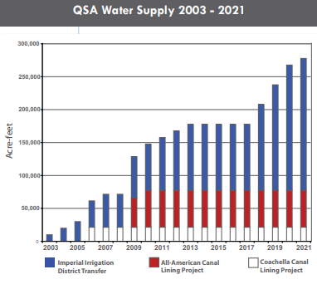

Under the 1931 priority system that has formed the basis for the distribution of Colorado River water made available to California, Metropolitan holds the fourth priority right to 550,000 acre-feet per year. This is the last priority within California’s basic apportionment. In addition, Metropolitan holds the fifth priority right to 662,000 acre-feet of water, which is in excess of California’s basic apportionment. Until 2003, Metropolitan had been able to take full advantage of its fifth priority right as a result of the availability of surplus water and water apportioned to Arizona and Nevada that was not needed by those states. However, during the 1990s, Arizona and Nevada increased their use of water from the Colorado River and by 2002 no unused apportionment was available for California.

Reservoirs in Lower Colorado River Basin

The two largest reservoirs in the Colorado River system, Lake Mead and Lake Powell. Lake Powell is for the upper basin and lake mead for the lower basin. The sequence of lower Colorado basin reservoirs/dams is as follows:

Hoover Dam/Lake Mead, Davis Dam/Lake Mohave, Parker Dam/Lake Havasu, Palo Verde Diversion Dam, Imperial Dam (Other minor dams have been omitted, more can be found on excel).

Lake Havasu: Colorado River Aqueduct

Palo Verde Diversion Dam:

Imperial Dam: All American Canal

MWD: Lake Havasu

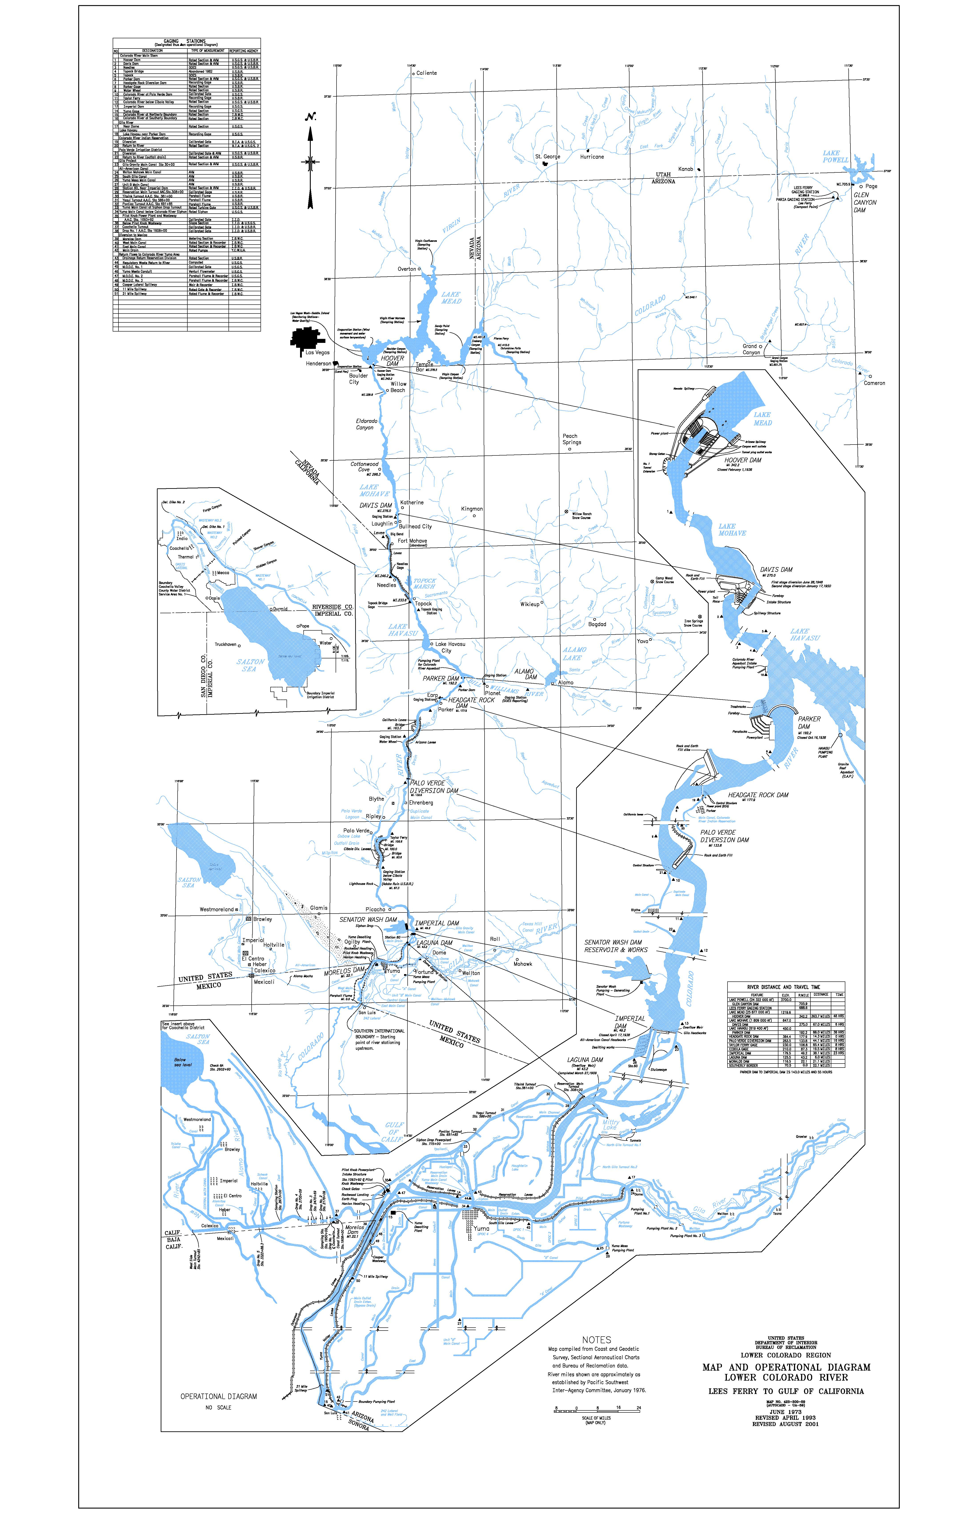

Colorado River is experiencing an ongoing drought since 2000 which has led to Lake Mead and Lake Powell reaching their lowest levels (“Megadrought in Southwestern North America Is Region’s Driest in at Least 1,200 Years,” 2022). Figure below shows how storage levels have decreased.

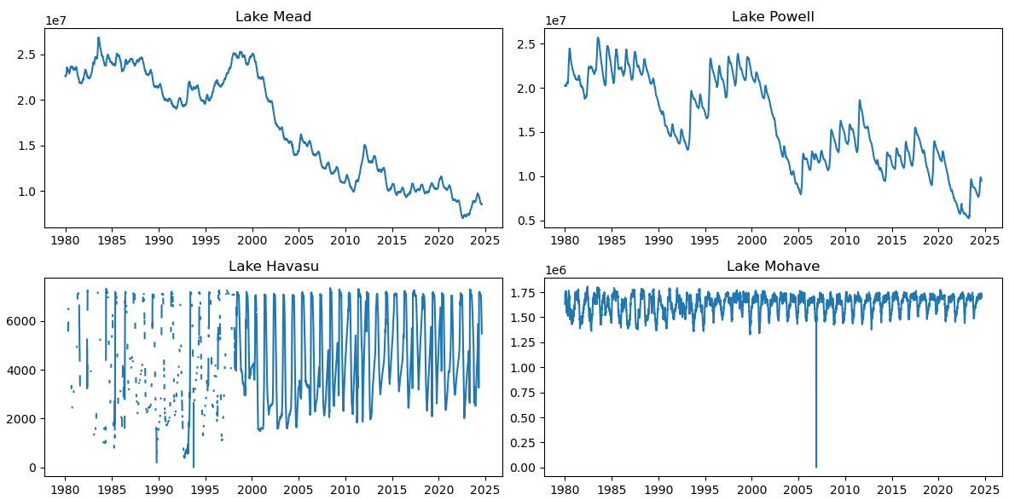

Talk about water agreements

### DWR (Water Data Portfolio)

SWDI delta is highly correlated with

### USBR

California has regularly used their full allocation of 4.4 maf from the Colorado River and frequently exceeded their share as shown in the figure below - 10yr average consumptive has been hovering around 4.5-5 maf from the 1970s up until 2000s. Since the early 2000s consumptive use has been decreasing which is due to persistent drought conditions at the Colorado river reservoirs.

Among the water users in California, PVID is the only water user that doesn’t utilize its full diversion as shown in figure below.

We also observe that IID and MWD diversions have more fluctuations compared to PVID and CVID. Mainly IID diversions have been decreasing since the 2000s because of urban transfers. Whereas MWD experiences fluctuations because its 4th in priority and its complex water supply portfolio, which does not solely rely on the Colorado River.

Our focus is on south coast deliveries which is MWD diversions. Since 2003, Colorado deliveries have decreased which can be contributed to 2 factors: 1 – drought conditions: Pre 2003, MWD was able to import more water than its allocation, but recent drought conditions have limited this; 2 – QSA (quantitative settlement agreement) which set a cap on the state's use of Colorado River water (again due to drought conditions).

Relationship with drought indicators

### MWD

### Validating Datasets

Here I compare USBR diversions with that of MWD. The data is similar with correlation of r2=0.87. Generally, consumptive use seems to be higher than what MWD claims to have received. It could be due to storage of water (According to MWD report, Colorado River Aqueduct supplies are gross Havasu diversions less return flows, deliveries to USBR, Mexico, and storage).

Comparing USBR consumptive use calculated in water year with DWR data shows a much lower correlation with r2=0.41 and MAPE 16%. DWR deliveries are generally higher than USBR, specifically for the years 2007, 2008, 2013 to 2015. This seems to be the case during drought periods, maybe there was an agreement to reduce consumption or storage of that water that I’m not aware of.

Although the comparison between MWD dataset and DWR dataset is not accurate because of differences in accounting between water year and calendar year. However, the correlation with MWD is higher compared to USBR (r2=0.7). MAPE for MWD (26%) is higher than DWR (16%), which is evident when comparing annual deliveries, The difference is more when comparing DWR to MWD – DWR deliveries are generally much higher.

# Estimating demands using drought indicators

# Summary

Focus is on B132 and Colorado river accounting reports:

## State Water Project

Key Findings

* Annual total deliveries:
  + Whole record period:1962 to 2022.
  + From each reach to each contractor
* Monthly detailed deliveries:
  + This is limited to the calendar year report was released
  + This includes:
    - Table A
    - Table A transfers (to/from others)
    - Carryover
    - Carryover transfers (to/from others)
    - Water Bank recoveries
    - Non-SWP transfers (to/from others)

Identified Gaps and Uncertainties

* Storage outside of service area (how much and which water agency is storing)
  + San Luis Reservoir
  + Semitropic Storage
* Uncertainty between total table8-7 monthly deliveries and table B-5B Annual deliveries in 2018 for MWD.
* Discrepancy between MWD dataset SWP deliveries and table B-5B Annual deliveries. Highlighted in section 1.e

## Colorado River

Key Findings

* Annual diversions to each user:
  + Whole record period
* Monthly detailed diversions to each user:
  + Whole record period

Identified Gaps and Uncertainties

* We don’t know how much is stored in Lake Mead (ICS)
  + We can extract it through reports
* We don’t know the monthly diversions to SDCWA
  + We have monthly deliveries up to 2011. After that it has been reported annually
    - We can extract it through reports
* There are other agreements that we are not considering such as:
  + interstate water banking
  + reservoir protection
  + Overruns, Paybacks, and Overrun Account Balances

The numbers are less significant, however, for some years it may become noteworthy (let’s say Nevada has been storing in Ca through interstate water banking).

# Appendix

State Water Project

Comparison of DWR dataset with MWD dataset and B135 SC is rather not completely valid since DWR dataset is in water year whereas the other 2 are in calendar year. However we do find that MWD dataset aligns more with DWR (r2=0.79) compared to B135 (r2=0.4925).